**Audio**

1. **2.**

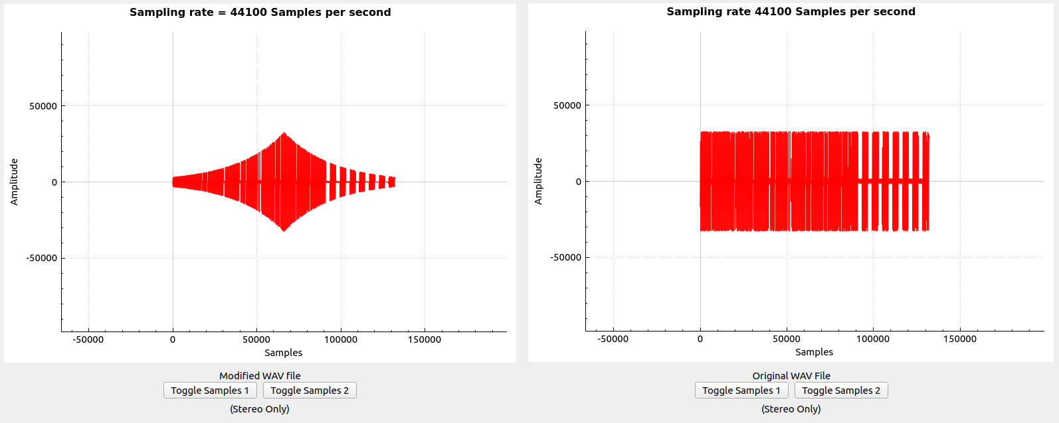

For Question 1, refer to “Original WAV File” on the right for original Cowbell-mono.wav without fade in, fade out.

For Question 2, refer to “Modified WAV File” on the left for the Cowbell-mono.wav with fade in from -20db to 0db and fade out from 0db to -20db

**4. 5.**

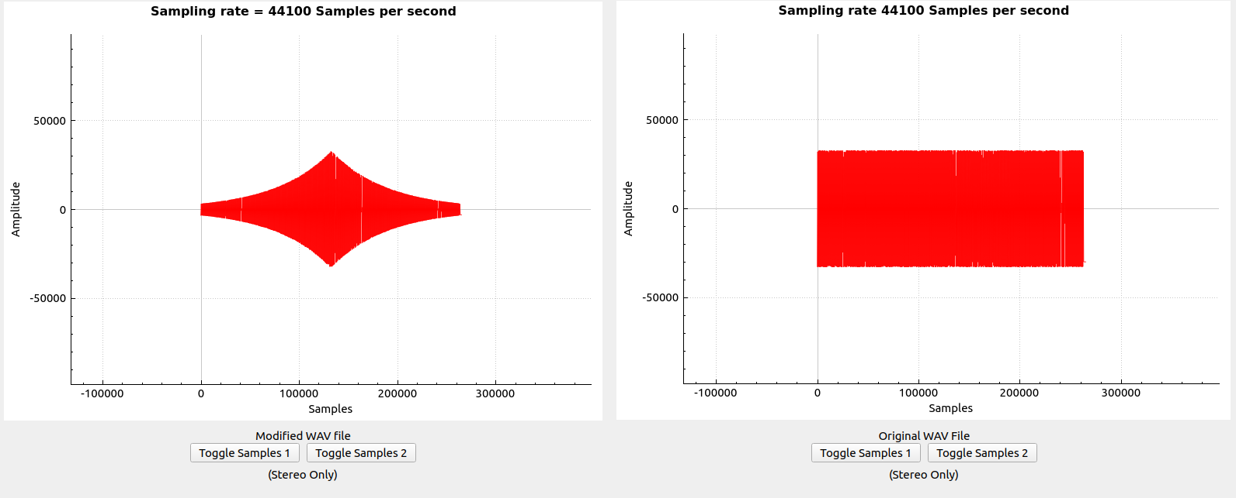

For Question 4, refer to “Original WAV File” on the right for original ImperialMarch-mono.wav without fade in, fade out.

For Question 5, refer to “Modified WAV File” on the left for the ImperialMarch-mono.wav with fade in from -20db to 0db and fade out from 0db to -20db.

**5. 6.**

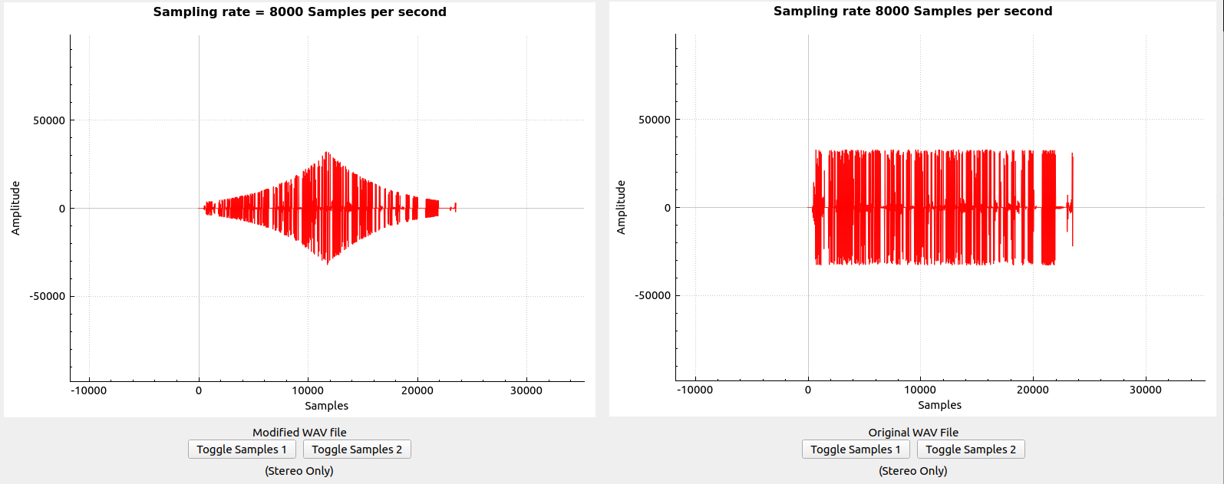

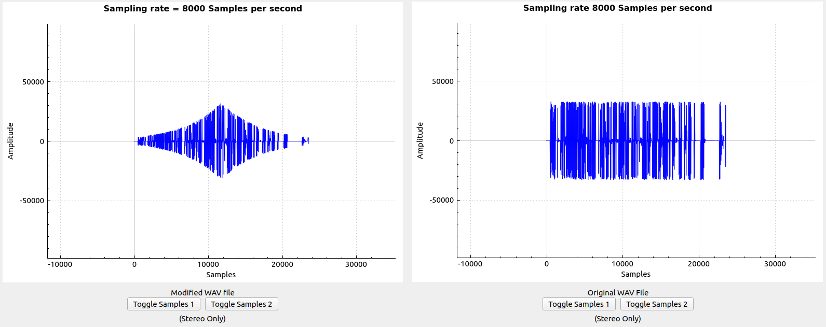

For Questions 5 and 6, I used a Stereo WAV file called “M1F1-int16-AFsp.wav” from the following site: <http://www-mmsp.ece.mcgill.ca/Documents/AudioFormats/WAVE/Samples.html>. The top set image represents set 1 of the samples(Left samples) while the bottom image represent set 2 of the samples(Right samples).

For Question 5, refer to the “Original WAV File” on the right of both images, without fade in, fade out.

For Question 6, refer to the “Original WAV File” on the right of both images, with fade in from -20db to 0db and fade out from 0db to -20db.

**7.**

To determine the fade in / fade out, I calculated the supposed amplitude per sample given and derived the following formula:

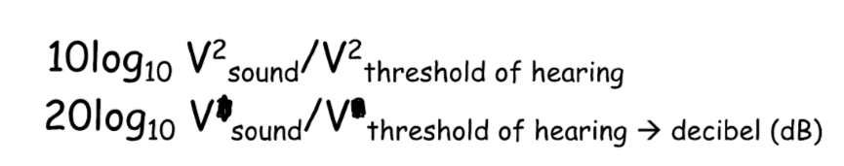

Substituting Vsound with Vin (Original amplitude) and Vthreshold of hearing with Vout(Calculated amplitude). As a result, given a certain dB and a Vin, we can get Vout with the equation:

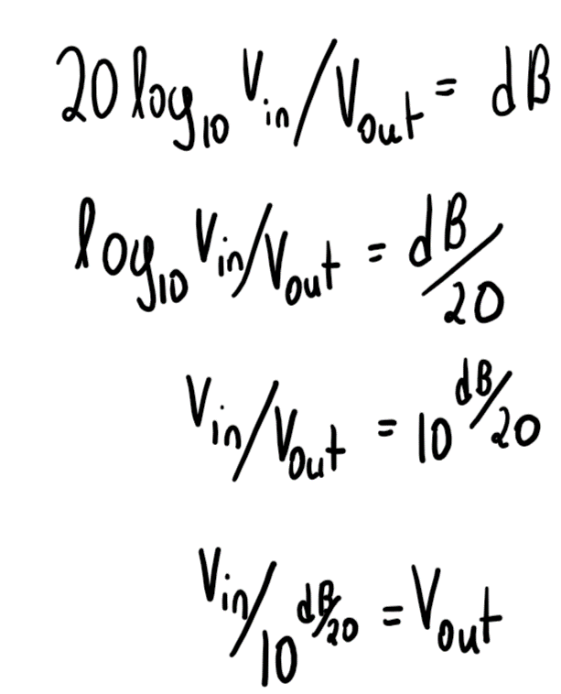

Given the relationship between Vin and Vout is not linear, when increasing dB linearly we can see exponential growth/decay on the samples as shown in the images previously.

**Image**

**1.**

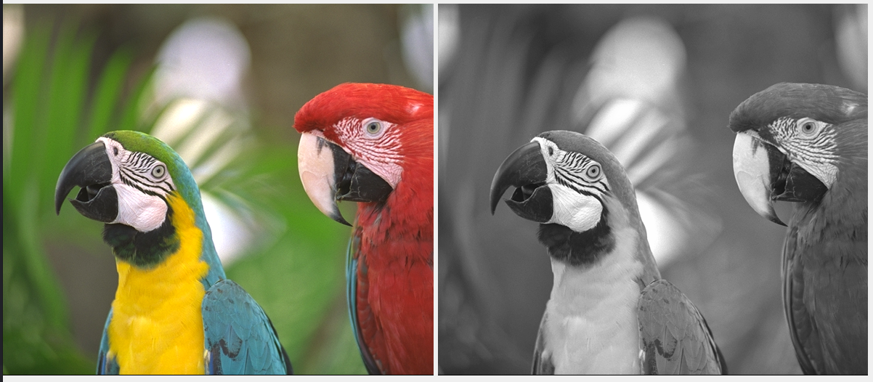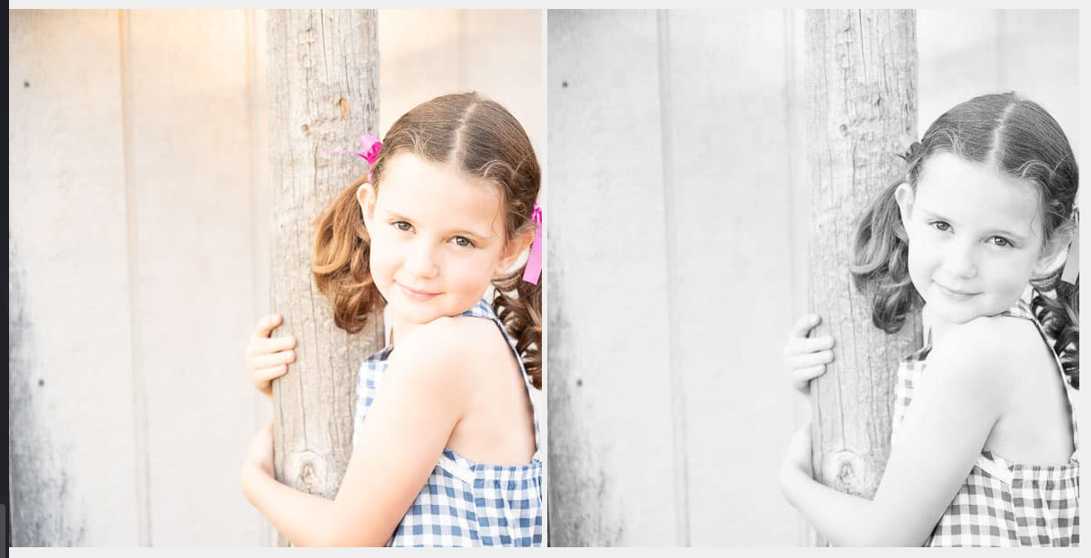

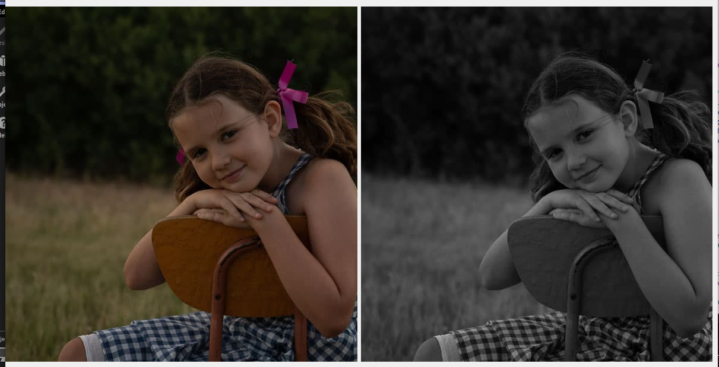

**2.**

To calculate the grayscale image, I modified each RGB pixel with the YUV color space weights (R * 0.299, G * 0.587, B * 0.114). Then, I calculated that corresponding grayscale value by adding the RGB values together and set each channel to that grayscale value. This method was suggested from the following source:

<https://www.kdnuggets.com/2019/12/convert-rgb-image-grayscale.html> (Linear Approximation)

**3.**

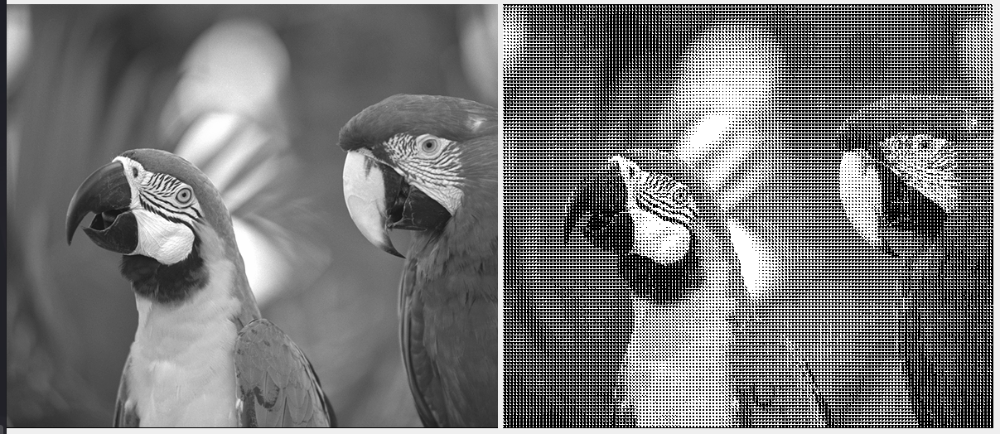

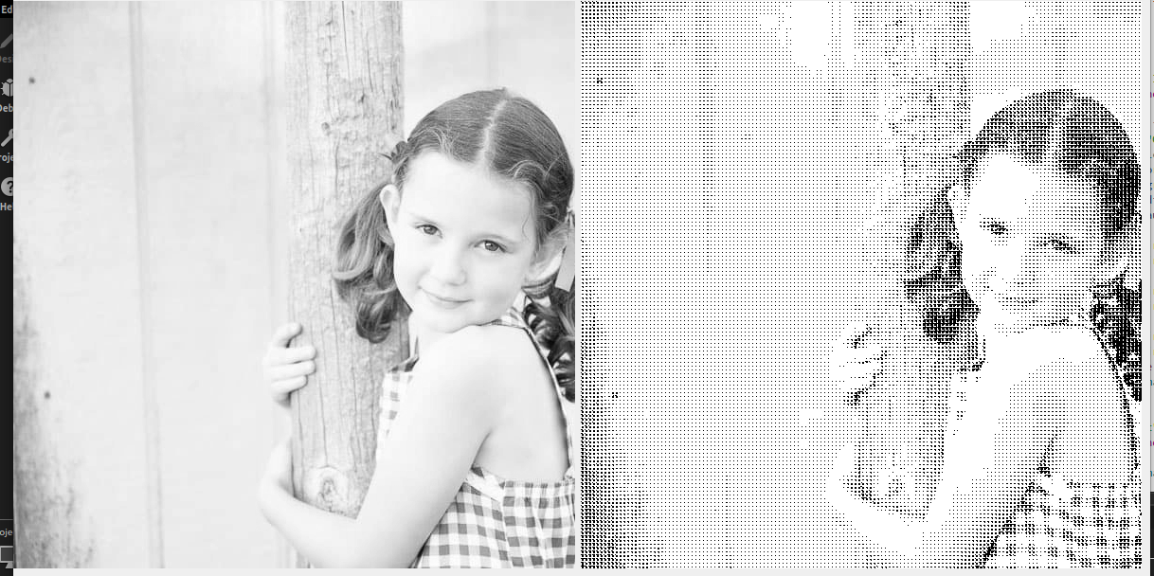

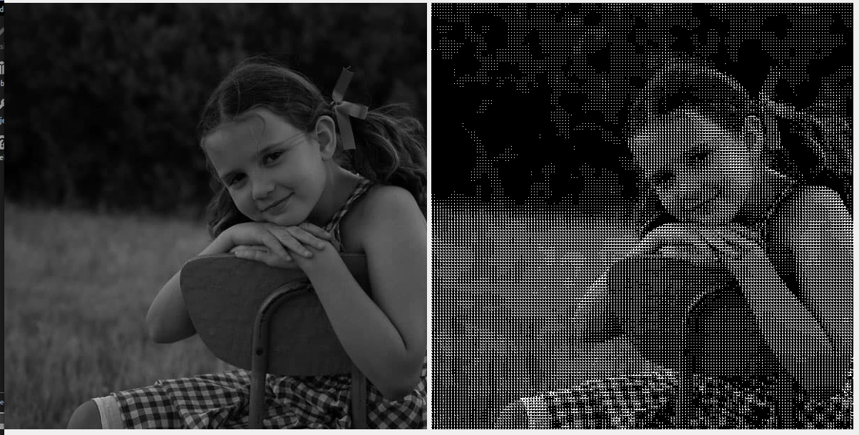

**4.**

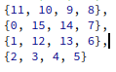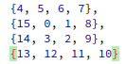Either matrix yielded similar results

**5.**

This dither matrix was chosen to plot dots as if they were large 4 x 4 dots. The matrix spirals from inwards to outwards, starting from 15 -> 0 clockwise.

Reversing the spiral does result in similar images. In bright images (such as the overexposed) the reverse spiral matrix seems to yield no difference at all.

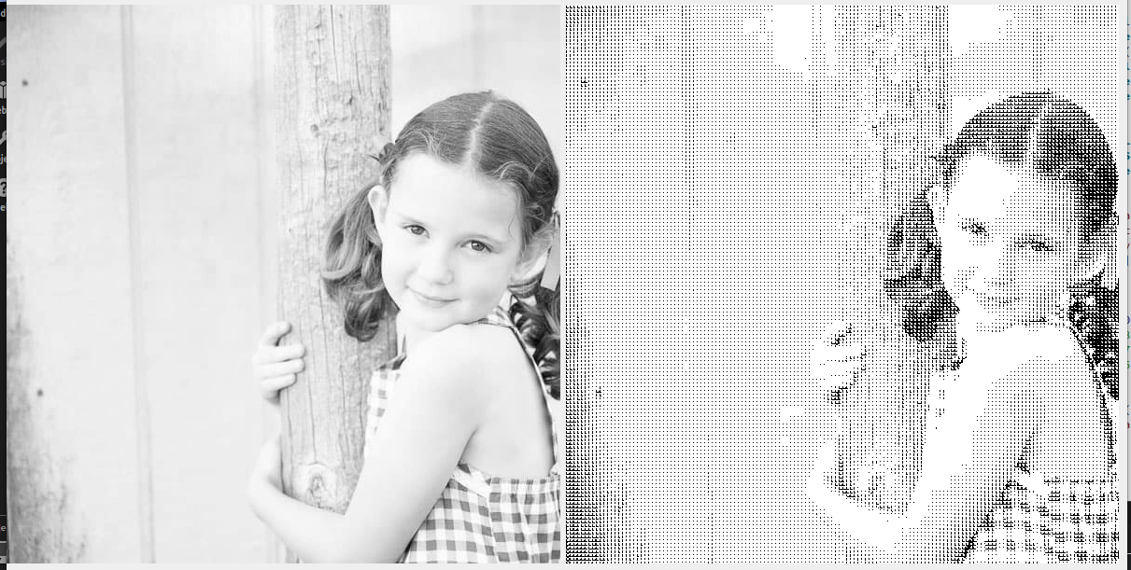

Nonetheless, this dither matrix and the reverse spiral of it seems to result in consistent dithering, given that how it is ordered is in a spiral. Unlike non spiral matrices, these ones tend to look more ordered, giving a more consistent gray scaling transition from white -> black and vice versa.

**6.**

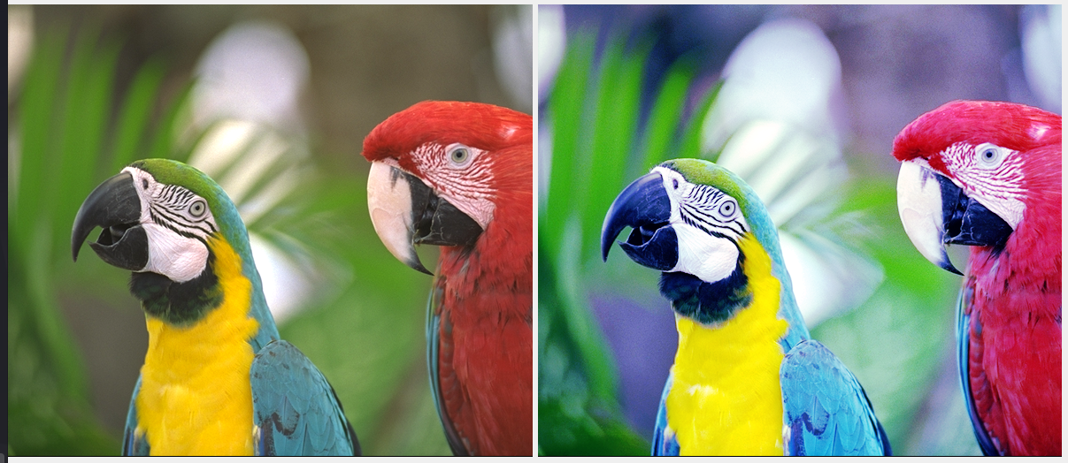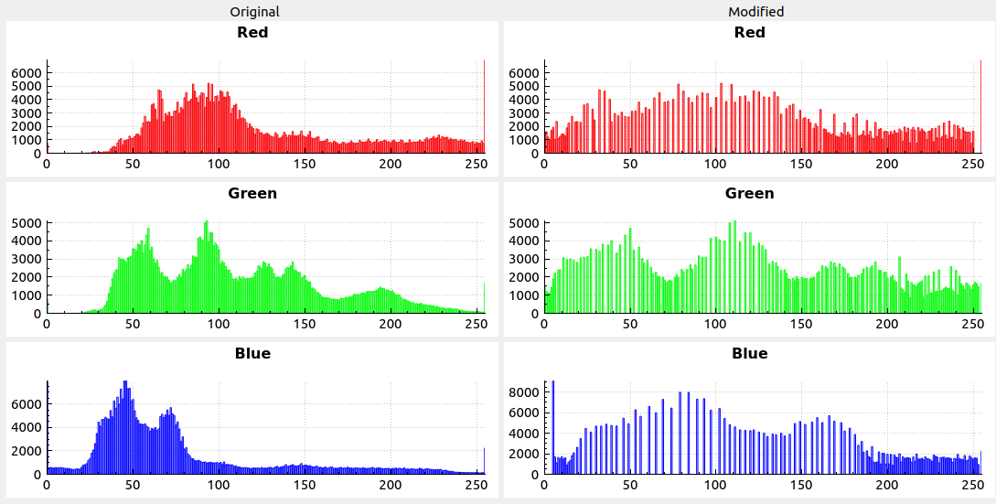

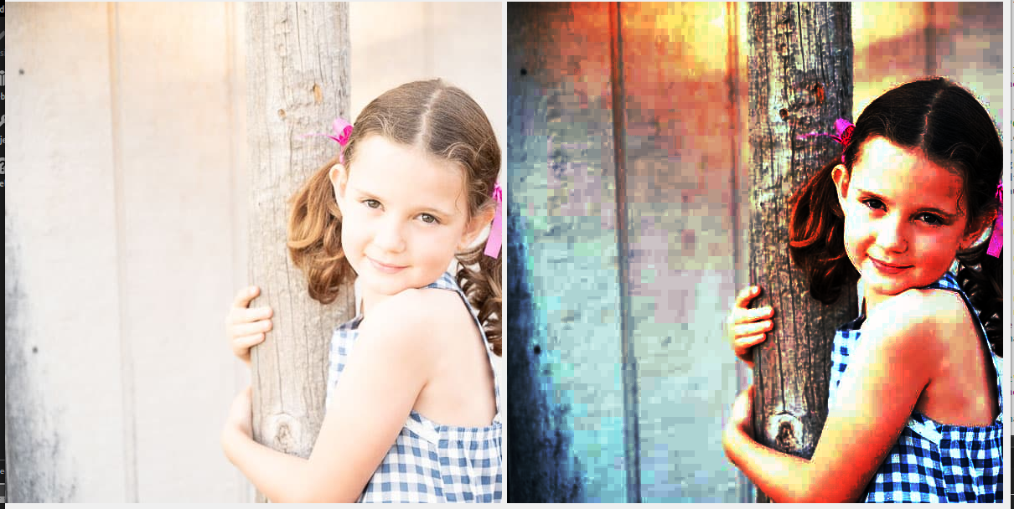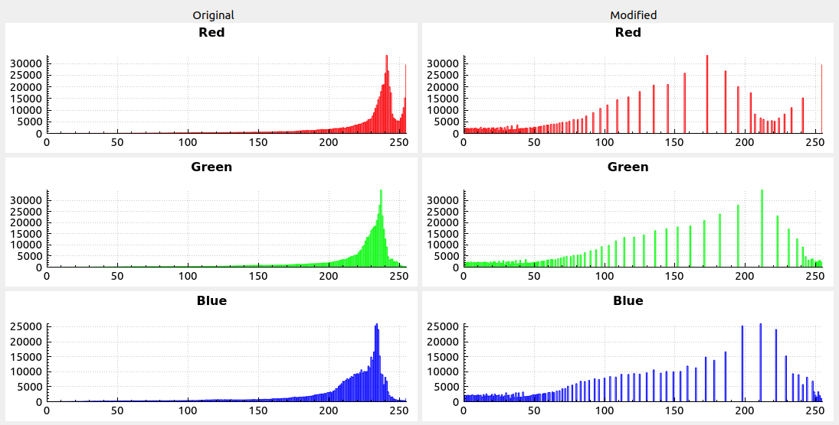

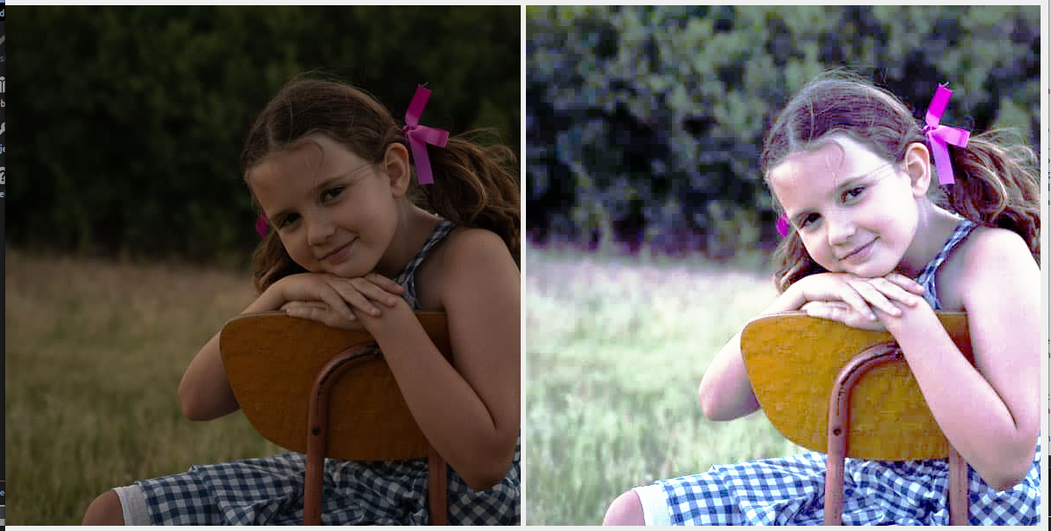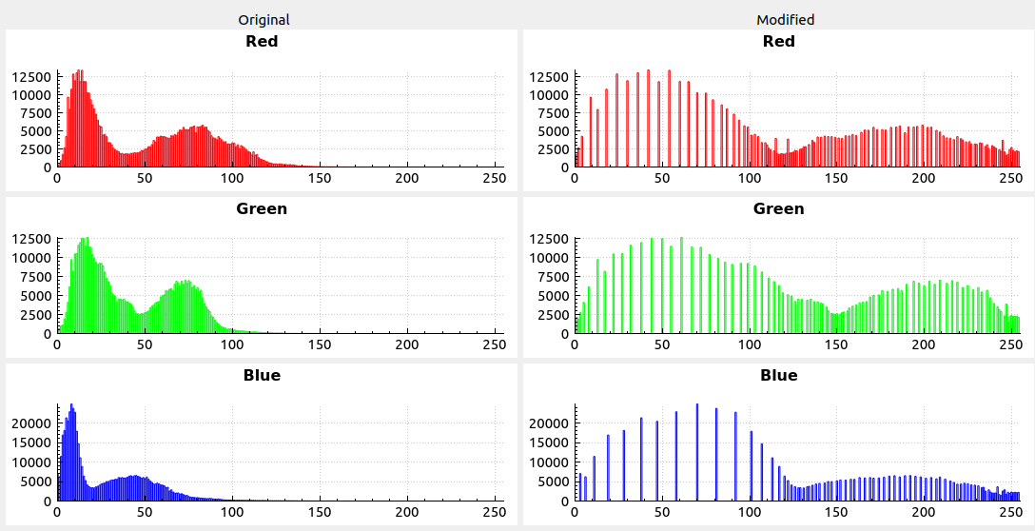

**7.**

Auto leveling the images was done via **Histogram Equalization**. This algorithm simply uses Probability Mass Function and Cumulative Distributive Function to determine the correct colors for red, green, and blue channels. Personally, I am not completely satisfied with this algorithm as in smaller images, pixels still appear blocky when looked up closely. This is especially true for the underexposed and overexposed sample BMPs.

Perhaps what I could have done was to centralize the distributions per channel and evenly spread it left and right as much as I can without leaving large gaps. There are noticeably large gaps between some color intensities, especially in the underexposed and overexposed BMP images.

Source: https://www.tutorialspoint.com/dip/histogram_equalization.htm

**8.**

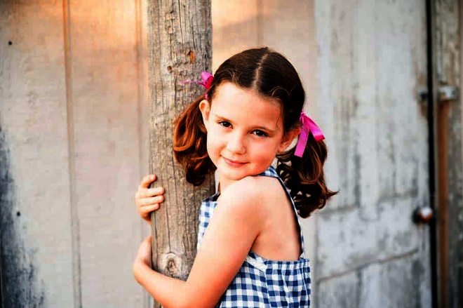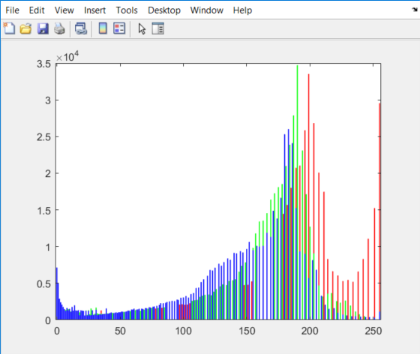

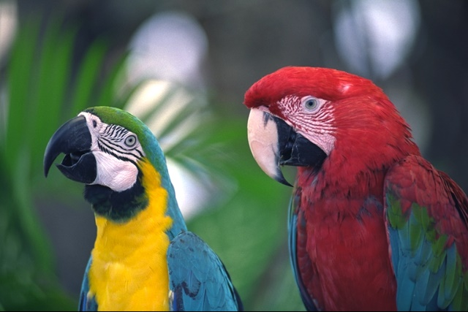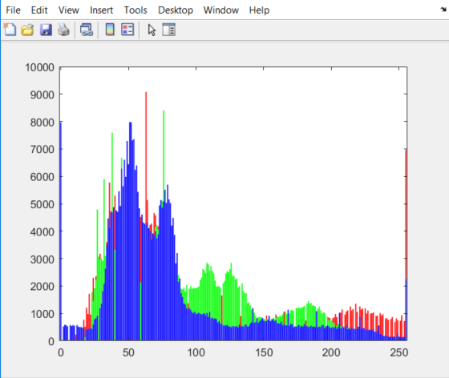

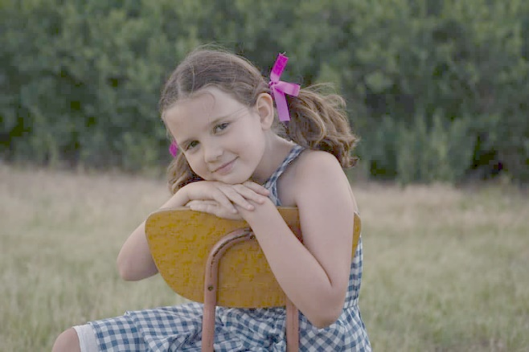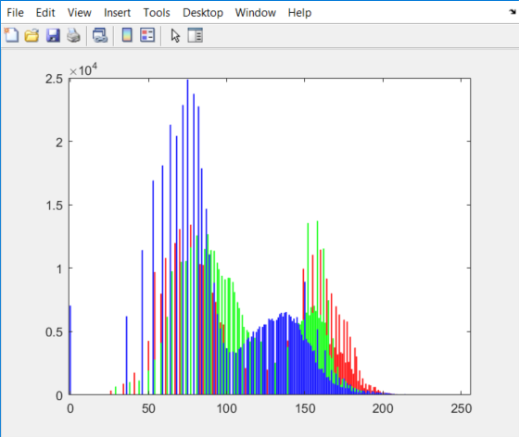

**9.**

For both the underexposed and overexposed images, I attempted to move the gray triangle cursor as seen in the picture below somewhere near in the middle of the presented histogram, but not exactly there. I followed a similar procedure to the parrot’s image, but I adjusted according to my preference. I attempted to get rid of most of the yellow tints by lowering the red and blue channels for the parrot image.

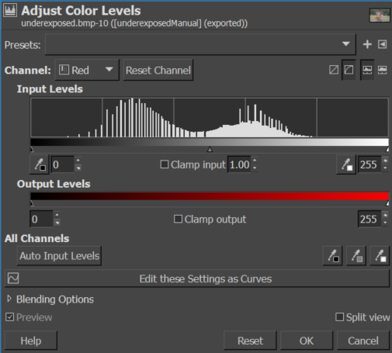



**10.**

I think the most noticeable difference is that the auto-level ran from my program seems to bring greater contrast and colour to the images. I think this is because the histogram equalization aims to stretch and include as much colour intensities as possible from 0 -> 255. When done manually the user perhaps simply one to tone one or two channels to their preference, given that human vision is sensitive to certain wave lengths (ex. Greater sensitivity to green wavelengths).

**Libraries used:**

For plotting wavelengths for audio and histograms for the image program, QTCustomPlot was used:

* <https://www.qcustomplot.com/index.php/introduction>

Reading WAV and BMP files were not done by external libraries.